Man Project
Instructions: we did all the research on question 1 – question 6, and I just need question 1 to 6 “put it all together” in essay format. The report should not be in Q&A format, but in essay format used for formal reports. Also, please format and organize into sections with titles, etc.,

This version of the report should address Q1 to Q6 above in report format (NOT in Q&A format) and should include supporting appendices (i.e., tables, charts, diagrams). Your report should not exceed 12 letter-sized pages (12-point font, double-spaced) not including the cover page and appendices, and cite all sources clearly. Please copy edit thoroughly before submission.

The objective of this exercise is to give you scope to apply relevant concepts, strategic analysis tools and techniques learned in class. Your strategic audit should address the following questions to the extent possible:
- What, very briefly, is the company’s background and history?
- What has the company’s strategy been over the years?
- What is the external context of the company? For instance, what aspects of the environment influence industry structure and performance? What are the paramount institutional constraints and how do they affect strategic choices within the industry? What drives competition within the industry? What are the most relevant measures of performance in the industry? What must a company be best at (i.e., key industry success factors) to do well in this industry?
- Describe the internal context of the company. For instance, what are the company’s valuable resources and capabilities? What are the company’s core competences? Is its internal organization, operations, systems and processes consistent with its environment and strategy? How has it been performing and how do you assess its future financial/strategic health?
- How does the company compare with its key competitors?
- What advantage does the company possess? How sustainable is this advantage and resultant performance?
- Currently, how global is the company in terms of its products/services and operations? Justify the need for the company to expand overseas and assess the benefits due to such expansion. Analyze the challenges that the company is likely to face in moving into different international markets. Describe the core competencies/advantages of the company and its ability to transfer them to different international locations.
- What are the key strategic challenges/issues faced by the company? What are your strategic recommendations (just three or four), given your answers to all the above questions? What are the time frames for these recommendations? What are the long-term competitive and performance implications of your recommendations?
- What implementation challenges do you anticipate?
- If you could implement only one of your recommendations, which would be it and why?

Answers:

- What, very briefly, is the company’s background and history?
About the Company Macy’s, Inc. is one of the nation’s premier retailers. With fiscal 2017 sales of $24.837 billion and approximately 130,000 employees, the company operates more than 690 department stores under the nameplates Macy’s and Bloomingdale’s, and approximately 160 specialty stores that include Bloomingdale’s The Outlet, Bluemercury and Macy’s Backstage. Macy’s, Inc. operates stores in 44 states, the District of Columbia, Guam and Puerto Rico, as well as macys.com, bloomingdales.comand bluemercury.com. Bloomingdale’s stores in Dubai and Kuwait are operated by Al Tayer Group LLC under license agreements. Macy’s, Inc. has corporate offices in Cincinnati, Ohio and New York, New York. Prior to June 1, 2007, Macy’s, Inc. was known as Federated Department Stores, Inc. The company’s shares are traded under the symbol “M” on the New York Stock Exchange.
Company History ( I KNOW IT’S A LOT, but I summarized it a bit…)
Macy’s started as s small, fancy dry goods store that opened on the corner of 14th Street and 6th Avenue in New York City in 1858. After several failed retail ventures, Rowland Hussey Macy at the age of 36 with the launched R.H. Macy & Co. He adopted a red star as his symbol of success, dating back to his days as a sailor. First-day sales totaled $11.06 but by the end of the first full year, sales grossed approximately $85,000. By 1877, R.H. Macy & Co. had become a full-fledged department store occupying the ground space of 11 adjacent buildings. Macy’s is known for several firsts that changed the retail industry. It was the first retailer to promote a woman, Margaret Getchell, to an executive position, making business history. Macy’s pioneered such revolutionary business practices as the one-price system, in which the same item was sold to every customer at one price, and quoting specific prices for goods in newspaper advertising. They were the first to introduce such products as the Idaho baked potato and colored bath towels. Macy’s also was the first retailer to hold a New York City liquor license. By November of 1902, the store had outgrown its modest storefront and moved uptown to its present Herald Square location on Broadway and 34th Street, establishing an attraction for shoppers from around the world. With the store’s 7th Avenue expansion completed in 1924, Macy’s Herald Square became the “World’s Largest Store,” with more than 1 million square feet of retail space. Note that Macy’s Herald Square expanded to 1.1 million square feet of retail space in the renovation project unveiled in 2015. By 1918, R.H. Macy & Co. was generating $36 million in annual sales. The company went public in 1922 and began to open regional stores and take over competing retailers. In 1923, the Toledo-based department store Lasalle & Koch was acquired; the next year, Davison-Paxton in Atlanta was acquired; and in 1936, the Newark-based Bamberger’s was purchased. To help celebrate their new American heritage, Macy’s immigrant employees organized the first Christmas Parade in 1924. The procession featured floats, bands, animals from the zoo and 10,000 onlookers, beginning a time-honored tradition now known as the annual Macy’s Thanksgiving Day Parade.
In 1945, the company expanded west and purchased O’Connor Moffatt & Company in San Francisco. Two years later, O’Connor Moffatt stores, including the landmark Union Square store that opened in 1866, were converted to Macy’s. Macy’s California broke new ground with the first department store flower show in 1946. What began as a fragrance promotion in the cosmetics department now annually welcomes the spring season, treating visitors to a botanical, cultural and community spectacle and is held in New York City, Chicago, Minneapolis, Philadelphia and Washington, D.C., in addition to San Francisco. In 1971, Macy’s Union Square store’s lower level, once cluttered with bargains, was transformed into “The Cellar,” changing the way customers shop for housewares. Due to its success, the Herald Square store followed suit five years later. On December 19, 1994, Federated Department Stores, Inc. (now known as Macy’s, Inc.) acquired R.H. Macy & Co., creating the world’s largest premier department store company. Federated Department Stores operated more than 400 department stores and 157 specialty stores in 37 states. A&S Department Stores were converted to the Macy’s nameplate in May 1995. Also in 1995, Federated acquired The Broadway Department Stores, bringing Broadway, Emporium and Weinstocks to the Macy’s family, as well as six former I. Magnin stores. Some 46 stores were converted to the Macy’s nameplate. Following the model of A&S, Jordan Marsh Department Stores of Boston, already owned by Federated, was converted to Macy’s in March 1996. In January 2001, Macy’s absorbed 17 Stern’s Department Stores located in New York and New Jersey. In June 2001, Federated purchased the Liberty House operations in Hawaii and Guam, bringing the proud Macy’s tradition and heritage to the Pacific.
Macy’s entered 2005 with about 240 locations, primarily on the East and West Coasts. With the conversion of all Federated’s regional store name-plates in March 2005, Macy’s grew to about 425 locations across the country. In September 2006, with the conversion of stores acquired from The May Department Stores Company, Macy’s served customers through approximately 730 stores. As of April 1, 2017, Macy's now serves customers through approximately 670 stores in virtually every major geographic market in the United States, as well as the macys.com website.
Reference: https://www.macysinc.com/

- What has the company’s strategy been over the years?

Corporate Vision

Macy’s, Inc. is a premier omnichannel retailer with iconic brands that serve customers through outstanding stores, dynamic online sites and mobile apps. Both Macy’s and Bloomingdale’s are known worldwide, and each has its own unique identity and customer focus. Bluemercury is widely recognized as the nation’s largest and fastest-growing luxury beauty products and spa retail chain.

Macy’s, Inc. clearly recognizes that the customer is paramount and that all its actions and omnichannel strategies must be directed toward providing a personalized merchandise offering and shopping experience online and in store.

Aggressive implementation of the company’s customer-centric strategies by a talented, experienced organization provides Macy’s, Inc. with an important competitive edge.

At Macy’s, Inc., our greatest strength lies in the expertise, judgment and talent of our people. Every day a production of enormous magnitude takes place on our selling floors and behind the scenes, where our people bring the company’s strategic goals to life. Our priority of attracting, retaining and developing the most talented people in the retail industry has been and will continue to be our greatest advantage.

JUST FOR REFERENCE: A LITTLE MORE INFO.

Corporate Financial Objectives
The financial objectives of Macy’s, Inc. are:
- To grow sales profitably;
- To maintain a profitability rate that is among best-in-class retailers, as measured by Adjusted EBITDA as a percentage of net sales;
- To improve return on invested capital; and
- To maximize total shareholder return.

I FOUND THIS REALLY INTERESTING AS WELL:

R.H. Macy chose the star as our company symbol when he first founded the business more than 150 years ago. It was derived from a red star tattoo on his forearm from his sailing days, and inspired by the North Star.

Five Points to the North Star Strategy
Point 1: From Familiar to Favorite includes everything we do to dial our brand to full bright at all touch points. Consumer research confirms the Macy’s brand is well-known and well-loved throughout the country and growing across the world. Actions in this point include understanding and anticipating our customers’ needs and strengthening our fashion authority, as well as executing initiatives around our loyalty and pricing strategies.
Point 2: It Must Be Macy’s is all about delivering the products and experiences our customers love and can only find with us. This includes styles and home fashion for every day and special occasions, from our leading private brands, as well as exclusive national brands or assortments found only at Macy’s. It celebrates our iconic events. This point also encompasses our strategies to appeal to more value-oriented customers in Macy’s Backstage and Last Act.
Point 3: Every Experience Matters, in-store and online. Our competitive advantage is the ability to combine the human touch in our physical stores with cutting-edge technology. We are enhancing our customers’ experience as they explore our assortments, find their favorite styles, sizes and colors, and receive their purchase through the shopping channels they prefer.
Our mobile app and digital capabilities complement the store experience and help our talented sales associates serve our customers better than ever. Macy’s app powers personalized recommendations, serves as a loyalty tool to deepen our customer relationships, and offers a simplified product discovery and checkout process. Our successful Buy Online Pickup in Store (BOPS) option will continue to provide customers with the omnichannel shopping experience they love.
Point 4: Funding our Future represents the decisions and actions we take to create resources to fuel our growth. We are focused on cost reduction and reinvestment, and creating value from our real estate portfolio.
Point 5: What’s New, What’s Next explores how we innovate to turn consumer and technology trends to our advantage and drive growth. This includes exploring previously unmet customer needs and making smart investment decisions based on customer insight and analytics. We’ll use these insights to improve our digital concepts, brand partnerships and acquisitions, while also innovating our internal processes and customer-facing ideas.

- Still missing and working on the answer.

- Describe the internal context of the company. For instance, what are the company’s valuable resources and capabilities? What are the company’s core competences? Is its internal organization, operations, systems and processes consistent with its environment and strategy? How has it been performing and how do you assess its future financial/strategic health?

Macy’s internal context is substantial and incredibly varied, from having one of the largest workforces in the U.S, to once being known as the leader of innovation, redesigning teen culture and always aiming for that top tier in management. Macy’s workforce is vast and innovative, offering an average of 166,000 jobs per year from 2010-2016, 75% being women and 65% being managers as well. Macys core competencies include managing capabilities, their relation with their suppliers, human capital as well as their marketing strategy. Even though for a good time this all worked for Macy’s their operating systems and processes didn’t catch up with the world around them. In this year 2018 Macy’s has had to close 11 stores and their profit has dropping year to year, this year dropping 13%. Here is a table of their recent struggle to remain a competitive company:
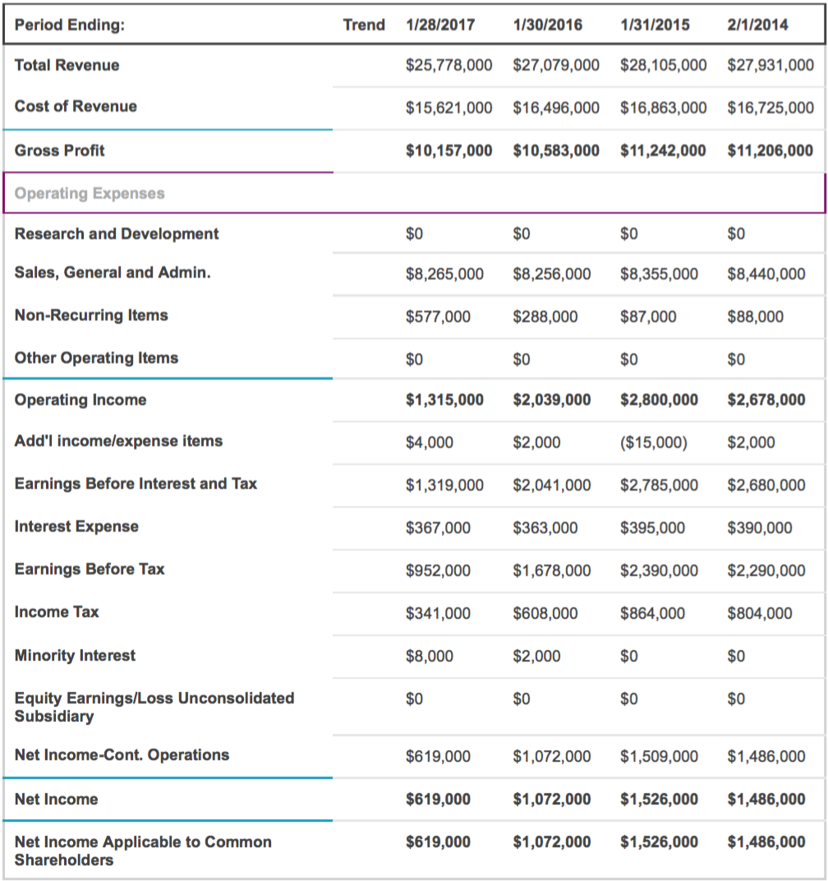
As you can see financially it is not performing as it was once was and I don’t see it getting any better. With how competition is in today’s day an age and how technology has advanced so drastically I don’t see how Macy’s financial health can withstand. The only way they can save this dip the company is facing is to make a new strategy and focus on what they need to advance. If they change their strategy and it works they might come back on top if not, it doesn’t seem to pretty.

References:
https://www.ukessays.com/essays/marketing/general-environment-analysis-of-macys-inc-marketing-essay.php
https://www.pivotalresources.com/macys-success-story/
https://www.usatoday.com/story/money/2017/05/11/macys-sales-profit-plunge-and-so-does-shares-price/101543670/
http://investors.macysinc.com/phoenix.zhtml?c=84477&p=irol-newsArticle&ID=2324867

- How does the company compare with its key competitors?
Still missing and working on the answer.

- What advantage does the company possess? How sustainable is this advantage and resultant performance?
Still missing and working on the answer.

